Instructions for Simulating Frequency in Sonnet

Abigail Shearrow, 06/22/2018

1. Import design: File > Import > DXF
   1. Import to new project to create a new project from design
   2. Import to existing project as template – this can be useful for simulating lots of devices, it allows you just make the dielectric stack, solution setup, and variables once and save the project as something new after importing.

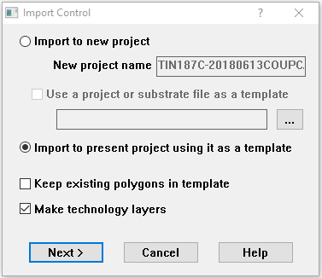

Keep the layers with your design:

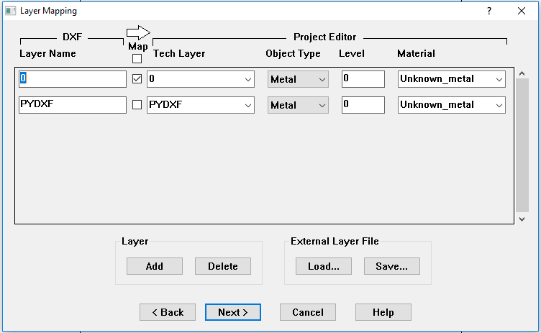

If you are importing to an existing template, you can choose the metal for your design here.

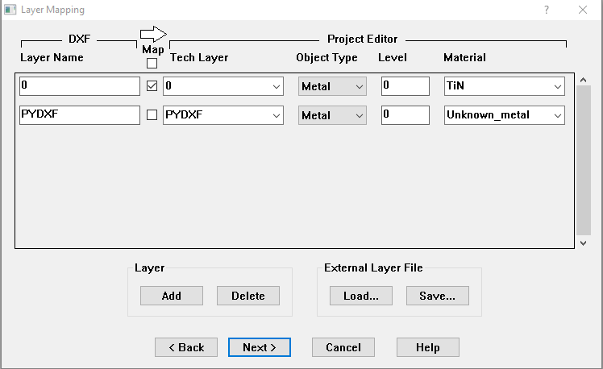

Make sure “imported units” matches your dxf. Add margins to box size as needed. Set cell size to be as desired. The cell size sets how fine your mesh will be. Sonnet just makes one mesh and then solves S21 at numerous frequencies. I have found that making the mesh size the same as or half the size of your smallest feature is good. This can still be changed once the design is imported, and there is a wizard to help you choose a good cell size, if you want to try that out.

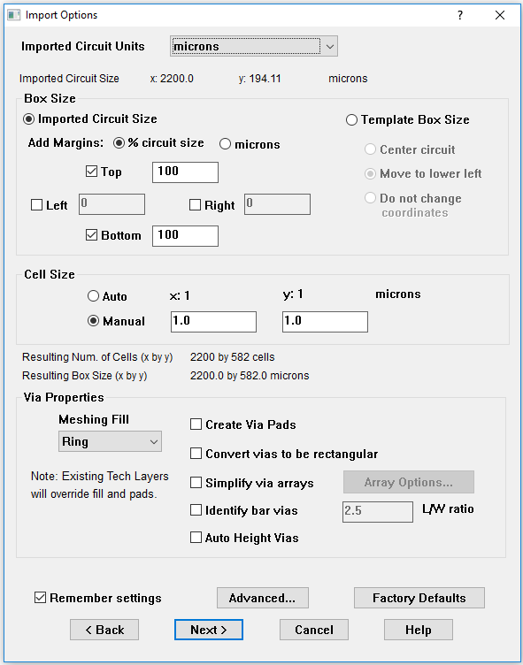

1. Follow the prompts to finish importing.
2. Edit > Boolean > Union to unite any parts of your design that you need to.
3. Dielectric stack-up:

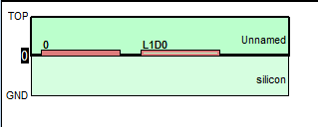

* 1. You can set the substrate and vacuum. You can also add new dielectrics to the dictionary by “Circuit > Dielectric Layers > Library > Add”
  2. The sheets shown in red are the metal layers. If it is just an outline of the box (like L1D0), then there are no shapes in that layer. You can choose the metal for a layer by double-clicking on the box in the stackup manager.
  3. You can similarly add metals to the library:

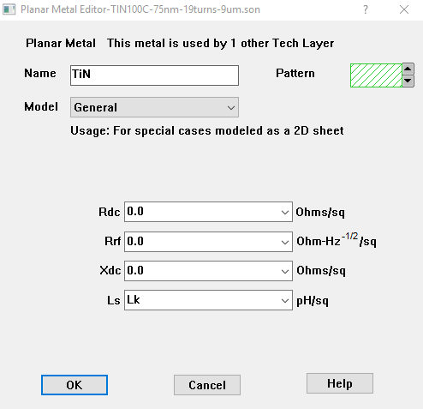

Choosing Model: General allows you to define the metal using the sheet inductance. I have done that here, and used “Lk”, which I defined to be a variable in “Circuits > Variable List > New…”. Making this parameter a variable allowed me to sweep the sheet inductance for each thickness of TiN. This meant running one simulation for each resonator design I was interested in.

1. If you are drawing around your features and need to subtract the design from a ground plane, use the Toolbox to draw a sheet for the plane. Once you select the sheet, you can also choose what layer you want the shape to be in from the drop-down menu in the toolbox.

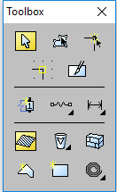 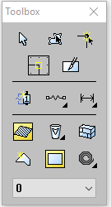

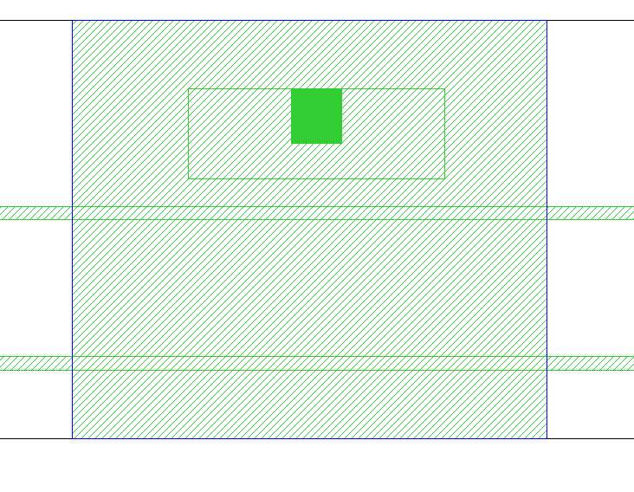

The green sheets are the metal. The sheet with the blue outline is the ground plane we’ve just drawn, and the black lines are the edges of our box (extend out of the picture). The box determines the area that the simulation will solve in – we will adjust the size of this box to fit our design size in a few steps.

Note also that the ground plane is much smaller than it would be in an ansys simulation. We do not need a large ground plane for this solver, but we just need to try a few different sizes to make sure that the box is large enough so that it’s not effecting the frequency solution. If the box is too small it will interrupt the field planes. Just try a few things out and see what works.

1. Subtract the resonator and CPW from the ground plane: Edit > Boolean Operations > Subtract
   1. Select the box to subtract from and hit enter
   2. Select the boxes that you want to subtract and then hit enter

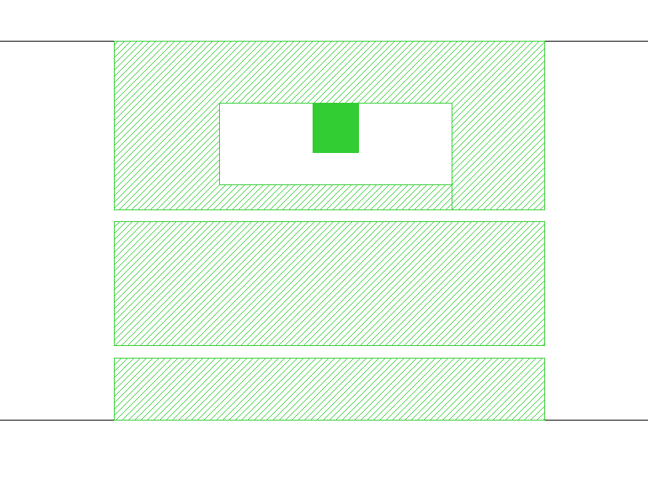

1. Adjust the box size to match the ground plane. Sheets which are touching the sides of the box are set to ground. Circuit > Box > “Set Box Size with Mouse”. Use the mouse to draw a box around your ground plane – it will auto-select to corners.

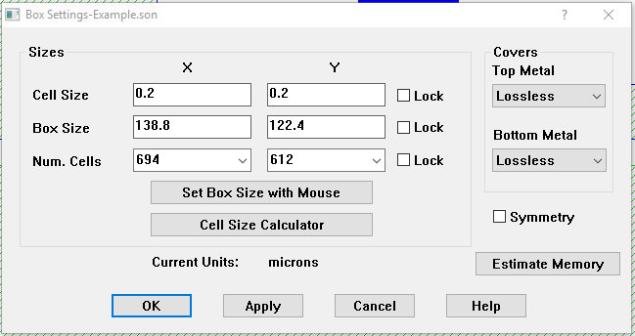

You can also use the wizard here to calculate a good cell size for the design. It will ask for 2 critical lengths in each direction. I would take these to be the 2 smallest feature sizes in each direction.

1. Add ports to the transmission line. From the toolbox, select the “ports” tool. Select the edges of your transmission line. The default is 50ohm, just set one to each end of the CPW.



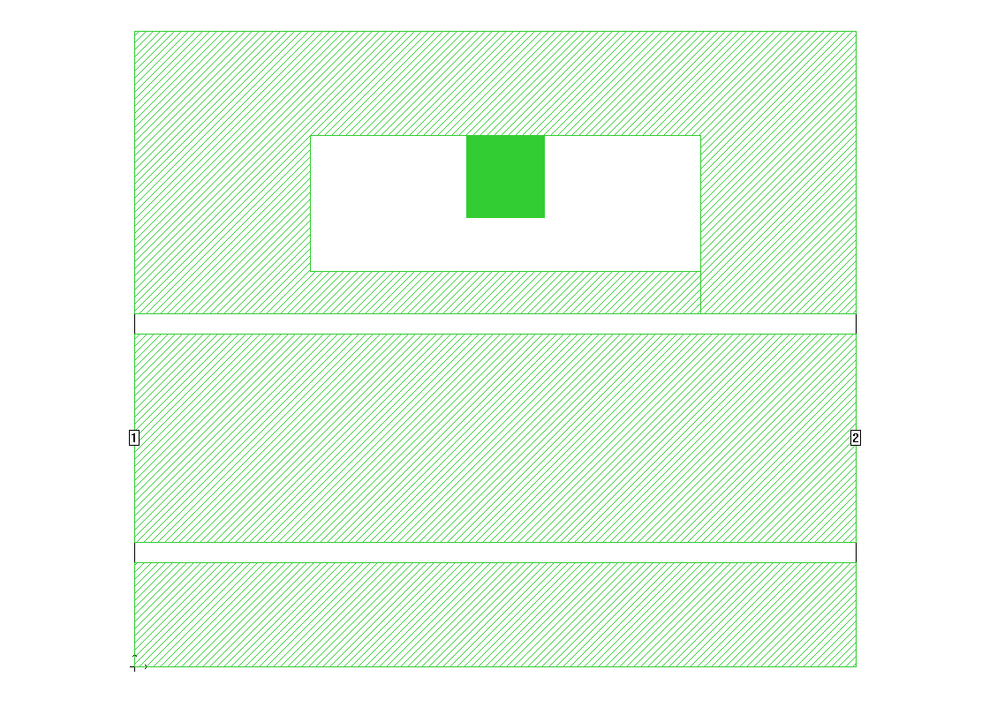

1. Solution set-up. Analysis > Setup:
   1. Choose the sweep type: Adaptive sweep is best for solving for frequency. It takes a few points in your range and solves there, then when it finds a resonance it goes back and solves more carefully around the resonance.

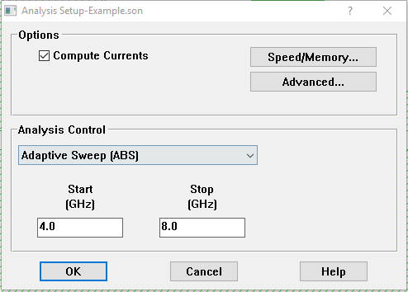

* 1. Set the range to solve over (I used 4.0 to 8.0 GHz).
  2. “Speed and Memory”: There is a trade-off between accuracy and speed here. Setting the counter to the middle makes the simulations run about twice as fast, but sometimes it misses my resonance. I would say if you know where your resonance is approximately, choose a smaller range to solve over and set the counter to the middle.

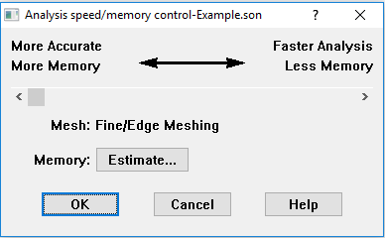

* 1. “Advanced Options”: Enhanced resonance detection tells it to go back and solve around the resonant frequency if it finds one. If you are having trouble getting it to find your frequency, increase the number of “automatic” frequencies from 300. The simulation will take longer, but this is just telling it to look at more points around each frequency.

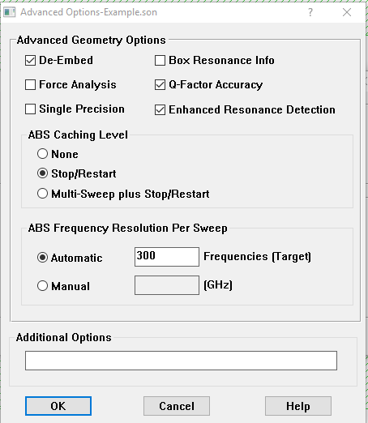

1. Running a parameter sweep: “Add”:
   1. Select variable from list
   2. Choose, start, stop values and step size
   3. You can also choose the sweep type here (you probably still want adaptive sweep for this). This means that it will run an adaptive sweep on the design at each of the values for the variable.
2. Estimate memory: Analysis > Estimate Memory. This subsections (meshes) the design to see how much memory it will take to run the simulation. Once you do a few of these, you can use this to approximately gauge how long it will take. If your simulation is taking longer than 15min, it may not be optimized. From this window, you can choose “view subsections”, and it will show you the mesh. Look at your smallest features to see if it has meshed them appropriately.
3. Save your simulation and run it: Project > Analyze. Unlike ansys, you can set up many designs and add them to a queue. The queue can be viewed under “batch list” in the analysis monitor (pops up when you run a simulation). You can change the order of jobs, stop or pause them, or set a time for the batch to start.
4. Viewing the results: Project > View Response > New Graph plots S11. You can double click on the “left axis” box to select S21 also. The circles are the frequencies that it solved at.

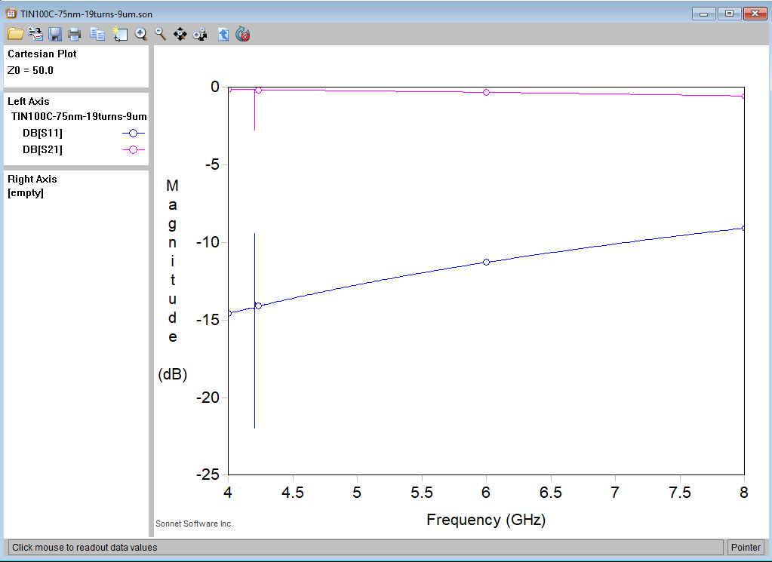

1. View currents, and get resonant frequency: Project > View Currents Select the frequencies that it solved at from the drop down menu. If it found the resonant frequency, the one with many more digits will be it.

